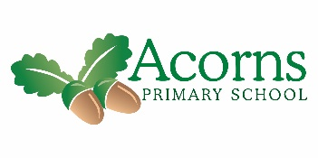

**Reminders**

Just a reminder that class snack/food tech money is £2 per week

**School will re-open on 7th January 2019**

**This Week...**

We have had a super week. On Monday we had a full dress rehearsal for the Christmas production and we enjoyed a delicious Christmas dinner.

On Tuesday it was party day and we had a very special guest! It was Santa with presents for all, Wednesday was the Christmas production in which we were all superstars.

On Thursday the class staff took us to McDonalds for lunch for working hard all term.

Then on Friday we celebrated pupil’s successes in our end of term assembly.

**W/B 17th December 2018**

Willow Class’s Weekly News

**And Finally**

Have a very merry Christmas and A happy New Year.

Best wishes

Paul, Nicola, Karen and Donna

**Next Week..**

Eat, drink and be merry. Have a fabulous Christmas.