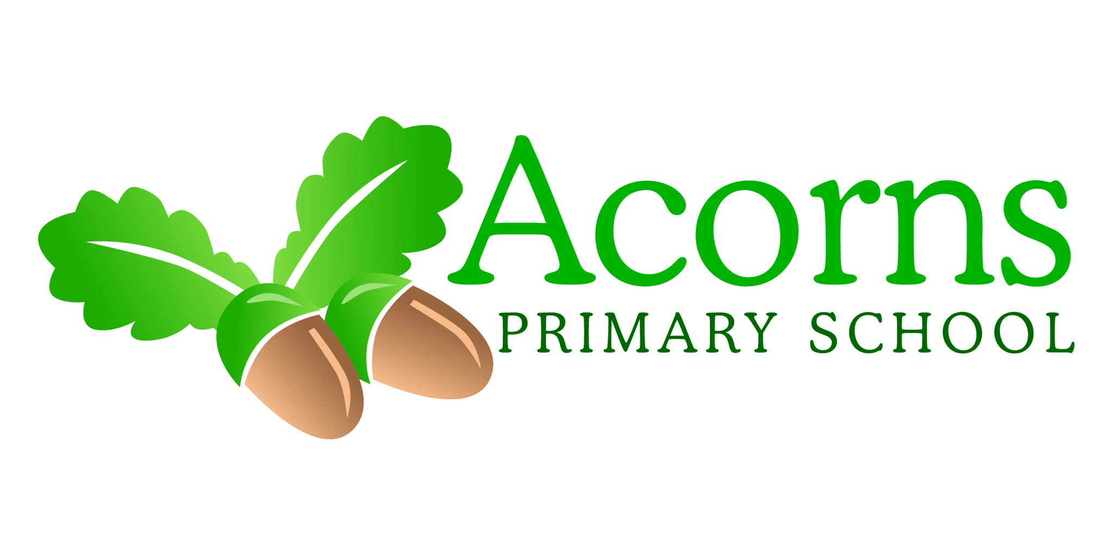

**W/B 17th December 2018**

Seedlings Weekly News

**After the holidays…**

**Our topic will be dragons and fairy tales if anyone has any pet dragons please feel free to send them in!!! ☺**

**This Week...**

**After a lovely busy and fanatically sparkly last week we’ve enjoyed crafts; music; presents; a visit from the big man in red; lots of yummy food and most importantly cuddles and happy children! We hope you all have a wonderful Christmas and we look forward to seeing all the children in 2019 for another great and exciting year!**

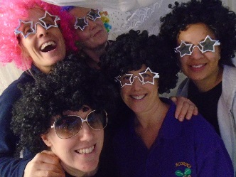

**Reminders**

Please email any Christmas/holiday photos to [lhall@acorns.lancs.sch.uk](mailto:lhall@acorns.lancs.sch.uk)

This would be greatly appreciated thank you ☺ Thank you for all the photos and emails sent this year – it is wonderful to see and this adds to the children’s learning journey files!



**And Finally…**

**Happy Christmas**